Solution to the problem that 6432G cannot be automatically reset after booting
1. Update the old version of RDWORKS software to the latest version, because the old version of the software may not be connected to the board.
2. Connect the board to the software.
a. Click the ‘Setting’.
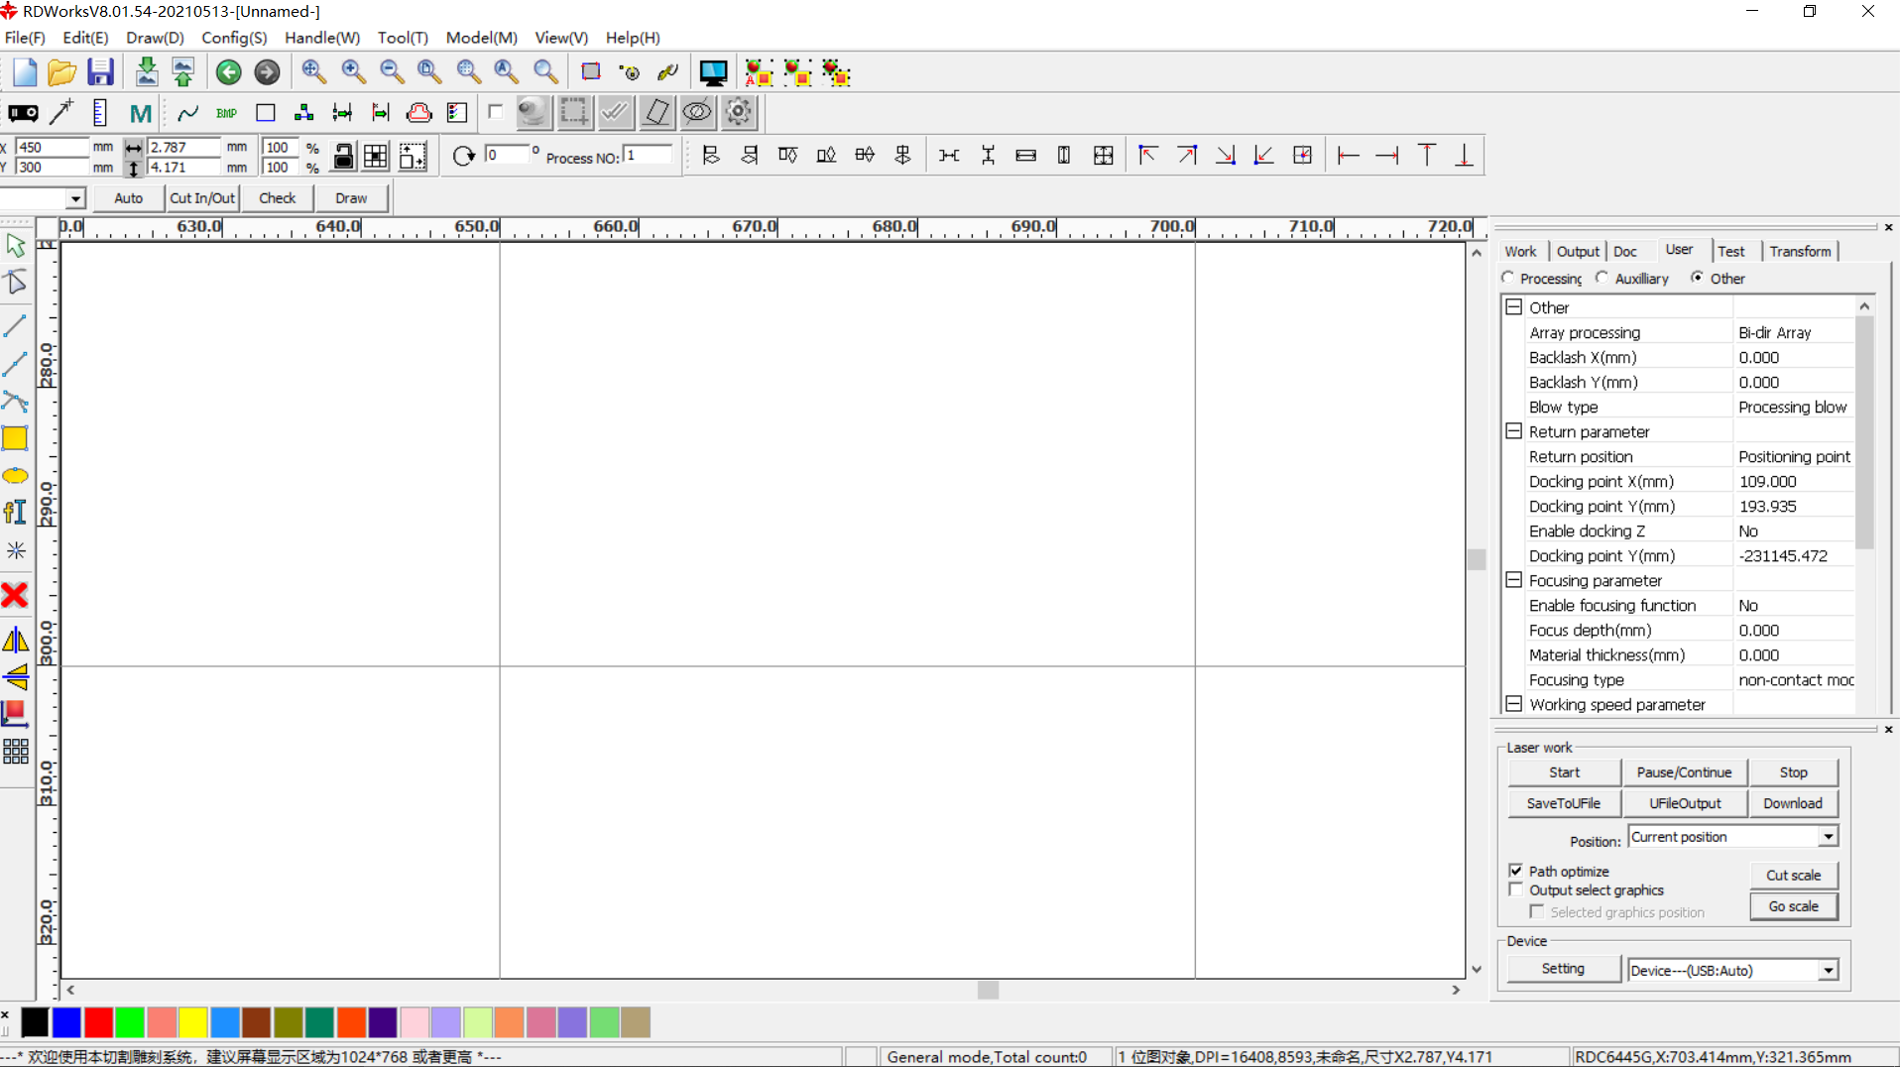
b. Double click on the blue area.
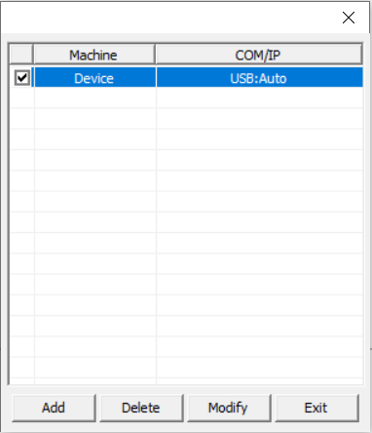
c. Click the ‘Test’.
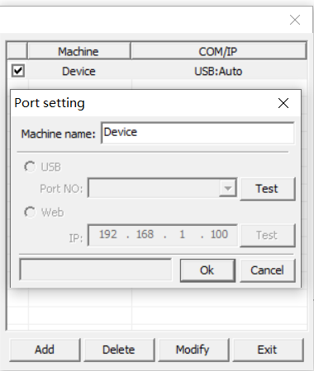
d. If the communication is successful, you will see the following interface.
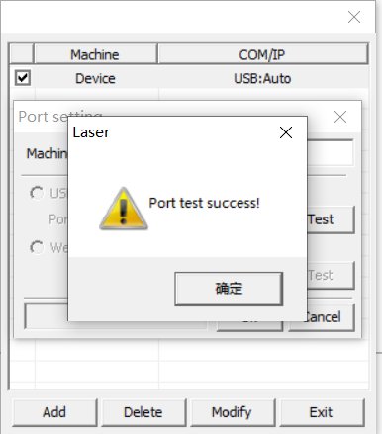
e. Click ‘确定’---‘OK’---‘’Exit’. You can click here on the software to observe whether the motor is running, and to determine whether the software and the motherboard are successfully connected.
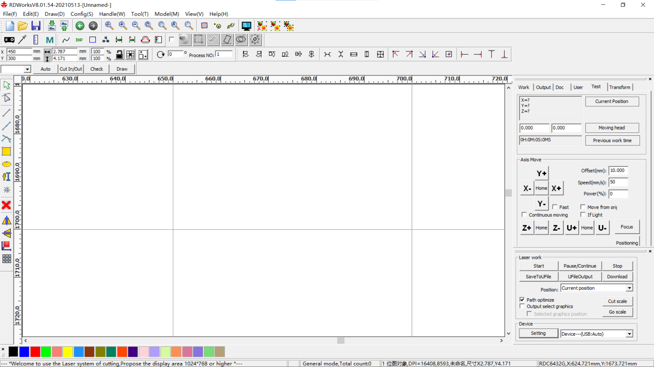
3. Click the ‘READ’to read the parameters from the main board. If ‘Auto home x’and ‘Auto home Y’are ‘Yes’, do not modify, otherwise change these two parameters to ‘YES’, and then click the ‘write’.
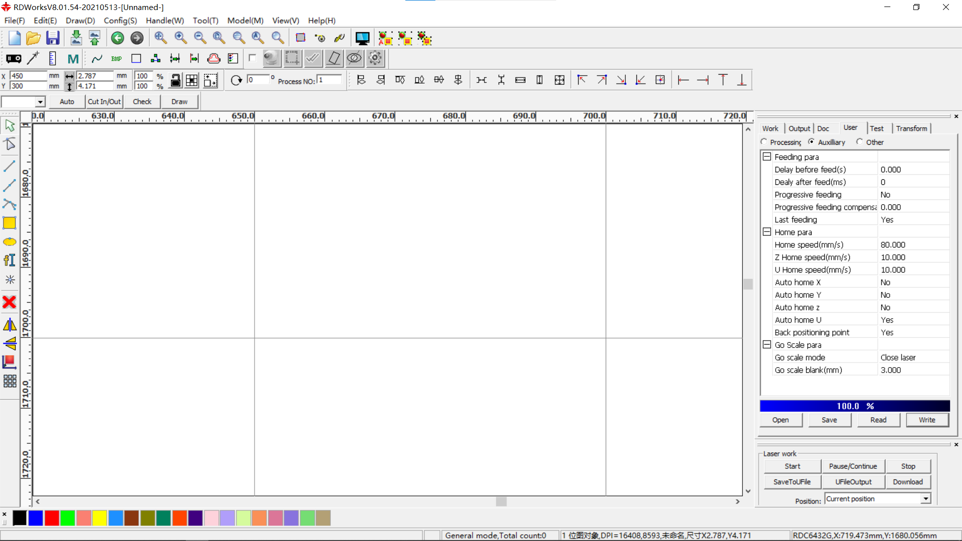
4.Click ‘Flie’---‘Vendor settings’. Input the password ‘RD8888’.
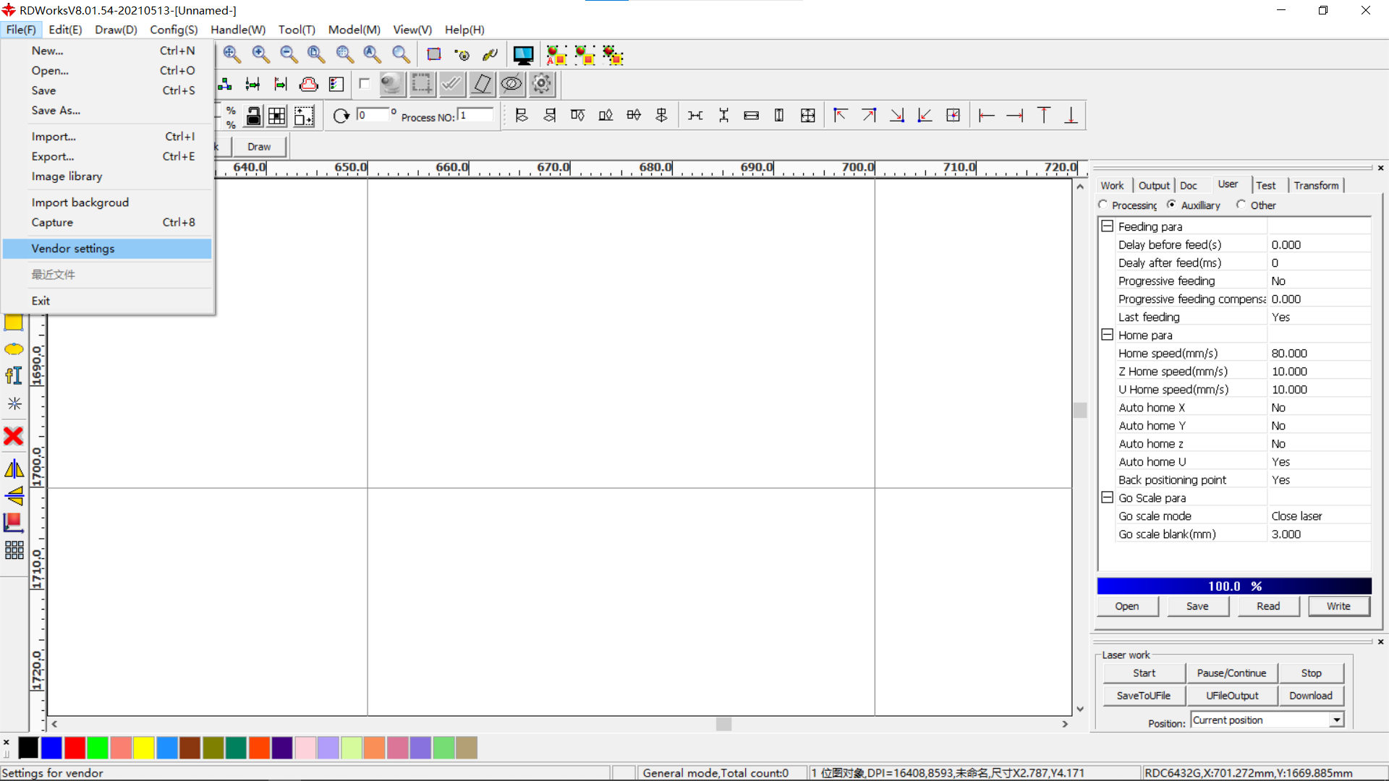
5. Set the X and Y axis respectively. ‘Read’---‘check ‘Enable HOME’’---'Write’.
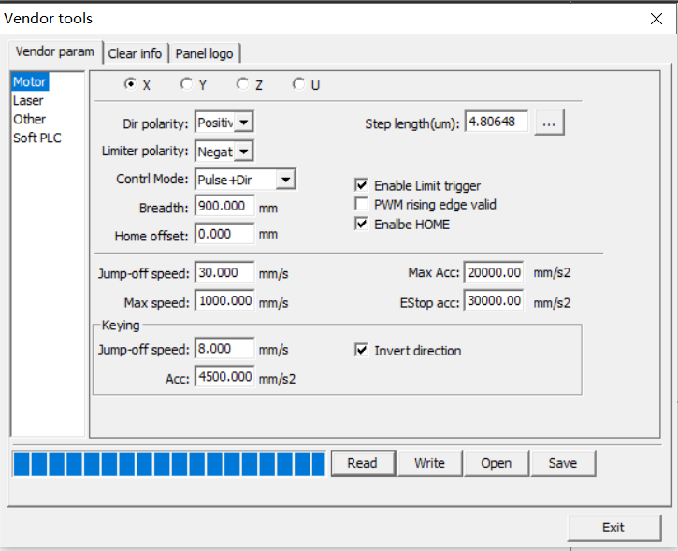
6. After the axis auto reset is successfully set, you will see the following screen when starting up.
