1.Overview.
The wireless handle BWK301-TTL consists of two parts: a wireless handle and a wireless receiver. The wireless handle establishes wireless communication with the wireless receiver, and the wireless receiver is connected to the RDC63XXG motherboard, so that the user can control the cutting process stably and reliably through the wireless handle within a certain range (40m), which is convenient for users to operate. The system allows users to operate the system immediately at the place of the processed object during the production process, without having to return to the console every time to operate the system through the operation panel, which improves work efficiency and is convenient and reliable to use. It works in parallel with the operation panel of the controller, and there is no interference and conflict with each other.
2.Wireless handle.
Wireless handle, as shown in Figure 2-1
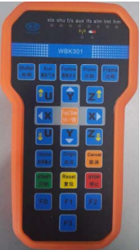
Figure 2‐1 BWK301‐B‐wireless handle remote control
The meaning of each button on the panel is as follows:
"Shutter":: Laser gate, laser enable/disable
"Aux": Turn on/off the auxiliary gas signal
"Follow": Turn on/off the follow signal, control the motor head to enter/exit the follow state
"Pulse"：The laser tube emits light
"Frame"：The current processing file is framed
"U +/- key"：U axis movement
"X +/-": X axis movement
"Y +/-"：Y-axis movement
"Z +/-"：Z-axis movement
"Fast/Slow": Set the cutting speed to fast/slow
"Home": Back to stop
"Origin": Set anchor point
"Cancel":Cancel
"Start":Start working
"Reset": Reset the motherboard
"Stop":Stop working
"F 0/1/2"：No (function customization key)
"F3"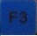：Turn on/off the blowing signal

For the description of the LED indicator of the wireless handle, see Table 2-1;
Table 2‐1 Description of wireless handle indicator
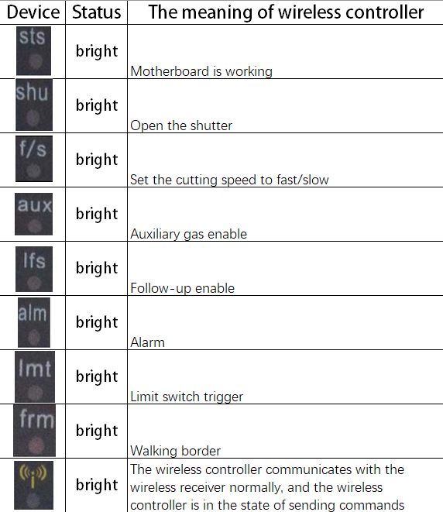
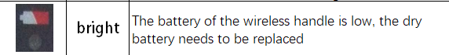

3. Wireless receiver
Connect DB9 to the motherboard
HMI port
BWK301-B-wireless receiver, as shown in Figure 3-1
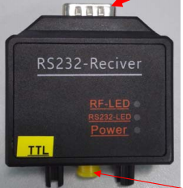
Antenna connection port
Figure 3-1 BWK301-B-wireless receiver

For the description of LED indicators, see Table 3-1;
Table 3-1 BWK301-B-Wireless Receiver LED Indicator Description
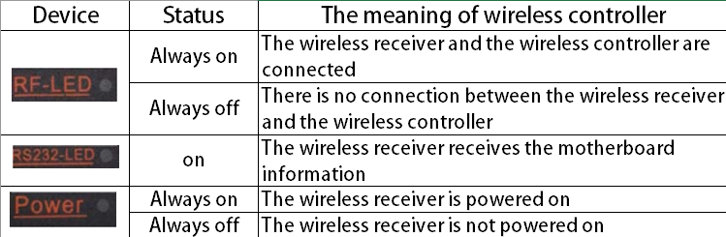
BWK301-B-wireless receiver DB9 interface wiring definition, see Table 3-2;
Table 3-2 BWK301-B-wireless receiver DB9 interface definition
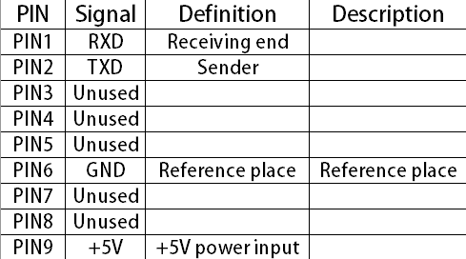
4. Description of the connection between the wireless receiver and the motherboard
4.1 Description of connection with RDC63XXG motherboard
When the DB9 port of the BWK301-B-wireless receiver is connected to the main board of the HMI interface of RDC63XXG, the connection between the BWK301-B-wireless receiver and the main board is shown in Figure 4-1.
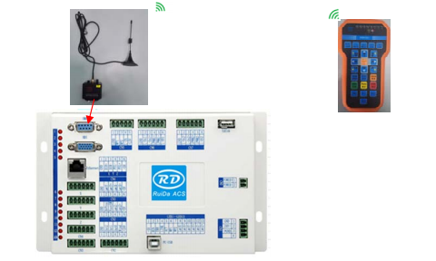
Figure 4-1 Wiring diagram of BWK301-B-wireless receiver and RDC63XXG main board

