How to set the rotation axis device in RDworks
- Connect the rotating, read the segmentation parameters of the corresponding driver.
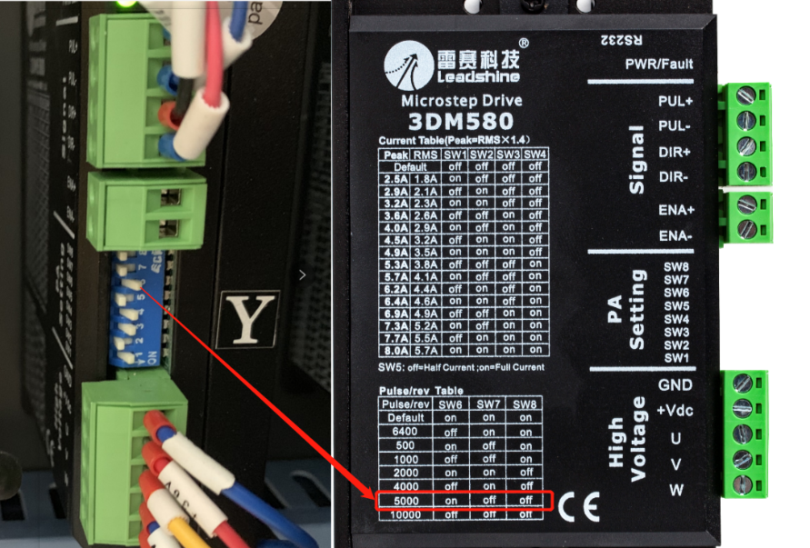

- Calculate and set the peripheral pulse and set the diameter of the workpiece.
Calculation formula of pulse count per rotate is as follows:

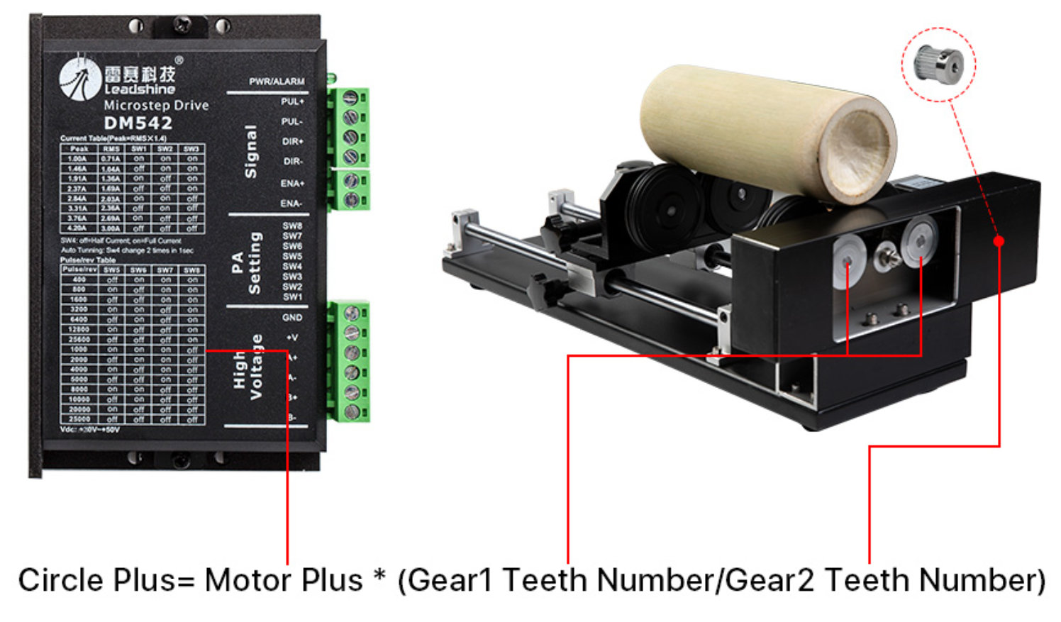
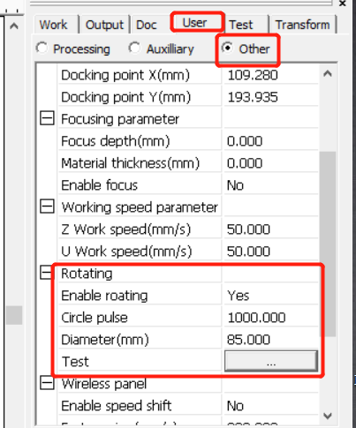
【Diameter】：The diameter of the parts to be processed.
【Circle Pulse】：The motor pulse when the workpiece rotated one circle.

- Import the files to be processed, process the file direction and size, and set the processing speed and power.
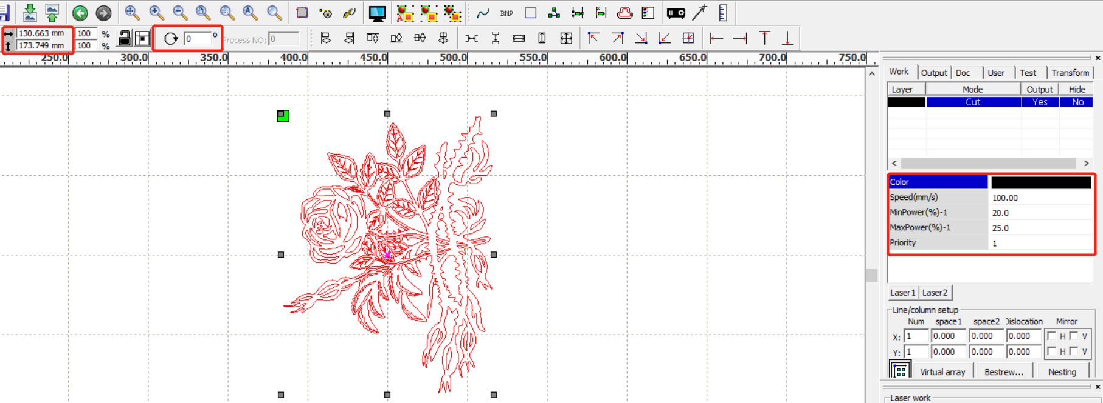

Note: The function is to facilitate the users to change parts, and different sizes of the workpieces are not very big. When the workpieces are in large difference, it is recommended to modify the motor step directly.
Rotary engraving is only when using the rotation axis to replace the Y-axis.

