https://cloudray2021.oss-us-west-1.aliyuncs.com/Product%20information/005.%20Laser%26Machine/EM-Smart/EM-Smart.zip
The above website is the address of EM-SMART marking machine software, please download
Once the download is complete, unpack the software
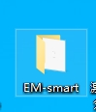

1:Open the folder,find
2:EM-SMART marking machine is powered on, and USB cable is used to connect the marking machine and computer
3:Open your computer's device manager
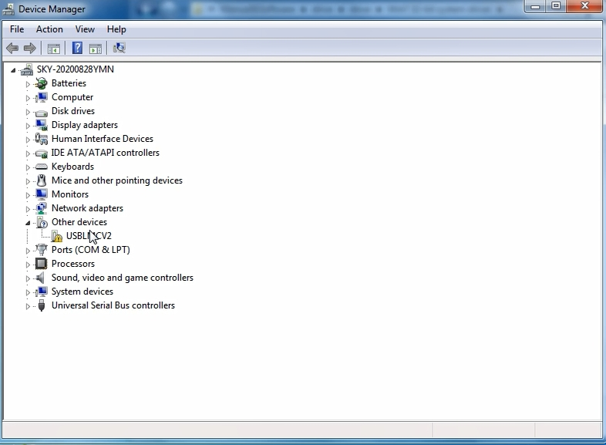
4:Click USBLMCv2 to update the USB driver. The driver file is 64-bit driver under EM-SMART folder

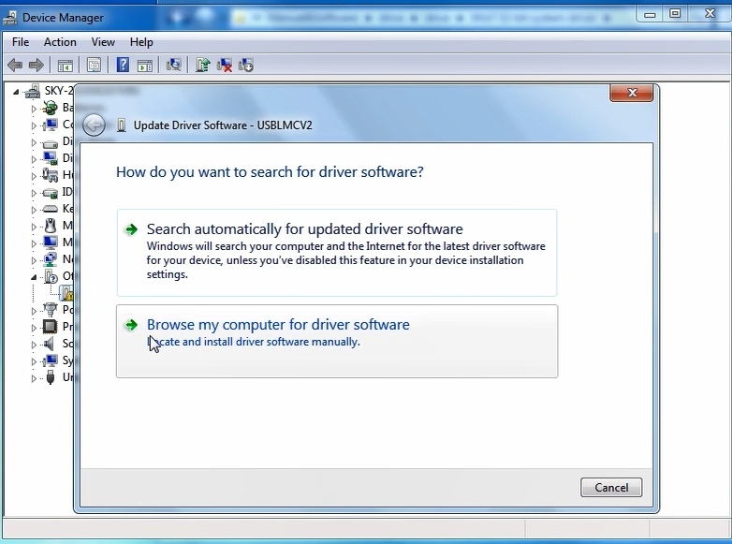

5:After the installation of the driver, the following interface will appear
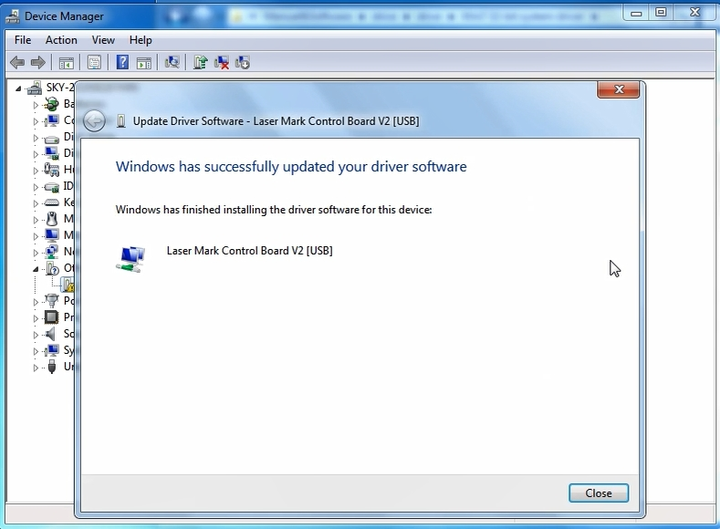
6:Open em-smart (20191219) -lite in the em-smart file and open em-smart under the em-smart (20191219) -lite.Exe file

